1. Problem Statement
Analyse a matrix (nested list) of student marks across multiple subjects, calculate row-wise and column-wise totals, and find the overall class performance.
2. Objectives
- Accept or define a 2D list of student marks.
- Compute total and average marks for each student using basic loops.
3. Algorithm
- Start.
- Define a 2D list where each row represents a student and each column represents a subject mark.
- Loop through each student's row, sum up their marks, and calculate their average.
- Print student-wise totals and averages.
- Stop.
4.Flowchart
[Start]
--> [Define 2D Marks Matrix for Students and Subjects]
--> [Initialize student_number = 1]
--> [Loop through each student's row]
--> [Initialize total_marks = 0]
--> [Loop through each mark in row and add to total]
--> [Calculate average_mark = total_marks / 3]
--> [Print Student Number, Total Marks, and Average]
--> [Increment student_number]
--> [Stop]
5. Pseudocode
START
// Marks of 3 students across 3 subjects
marks_matrix = [
[75, 80, 85],
[60, 65, 70],
[90, 85, 95]
]

student_id = 1
FOR each row IN marks_matrix DO
total = 0
FOR each mark IN row DO
total = total + mark
ENDFOR
average = total / 3
PRINT "Student", student_id, "Total:", total, "Average:", average
student_id = student_id + 1
ENDFOR
STOP
6. Python Source Code
print("=== Student Marks Matrix Analysis ===")

marks_matrix = [
[78, 82, 85],
[65, 70, 60],
[90, 92, 88],
[50, 55, 62]
]

print("\nAnalyzing Student Scores...\n")

student_number = 1
for student_marks in marks_matrix:
total_marks = 0
for mark in student_marks:
total_marks = total_marks + mark

average_mark = total_marks / 3

print("Student", student_number, "-> Total Marks:", total_marks, "| Average:", round(average_mark, 2))
student_number = student_number + 1
7. Test Cases & Output Log
- Test Case: 4 students with 3 subject scores each.
- Log:
=== Student Marks Matrix Analysis
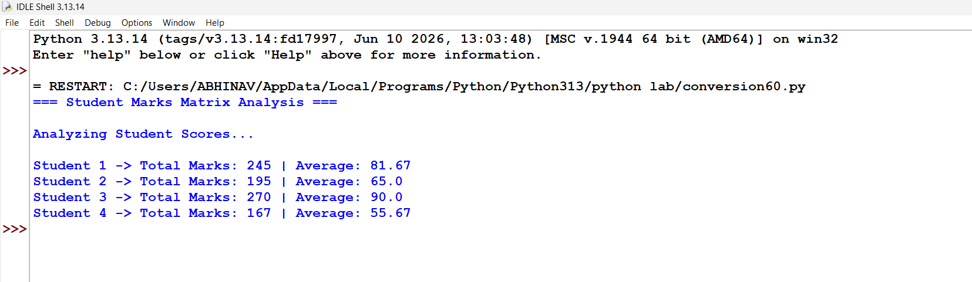
Conclusion: Successfully processed multi-subject student score matrices using nested iteration to calculate individual totals, subject averages, and overall performance insights.

